# Report on Faculty Survey during the Year 2015

The faculty survey at the end of the year 2015 was conducted through Google Forms randomly. There were 46 respondents including 8 Professors, 3 Associate Professors, 13 Assistant Professors and 22 Lecturers.

An overall response summary of questionnaires is presented in the heat plot below:

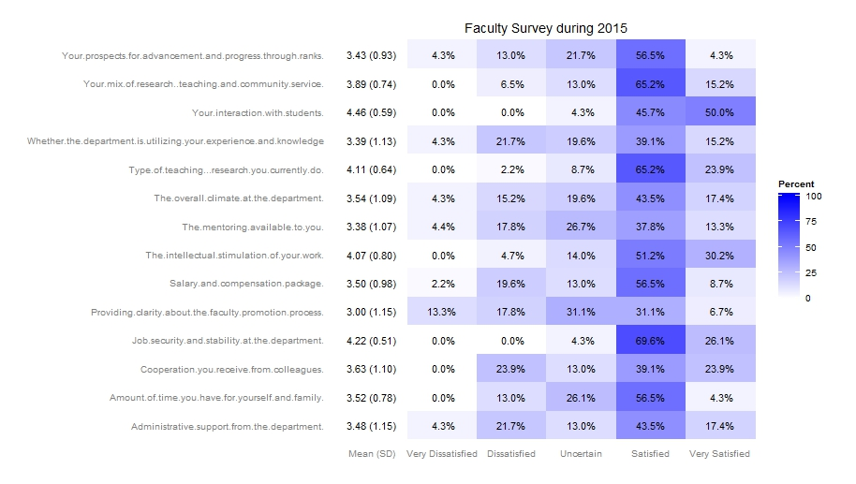

It is observed that lowest mean score is 3.00 with standard deviation of 1.15, while the highest score is 4.46 with sd=0.59. There are a few questionnaire responses which show somewhat a lower rating. The highest rated responses come from the questionnaire “Your Interaction with students”, while the lowest rated responses come from the questionnaire “Providing clarity about the faculty promotion process”. Further the plot above was bifurcated for various designations in the stacked bar graph below, which clearly shows each questionnaire’s response in percentages.

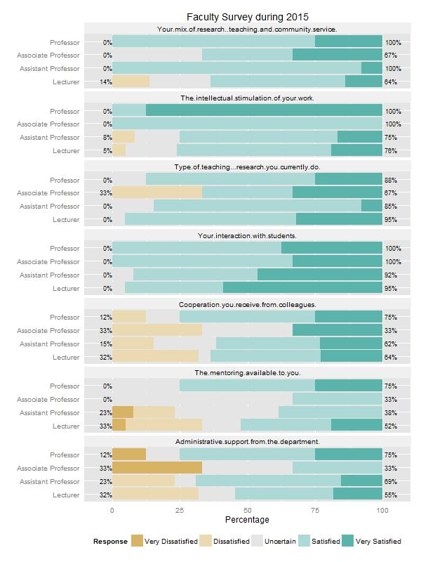

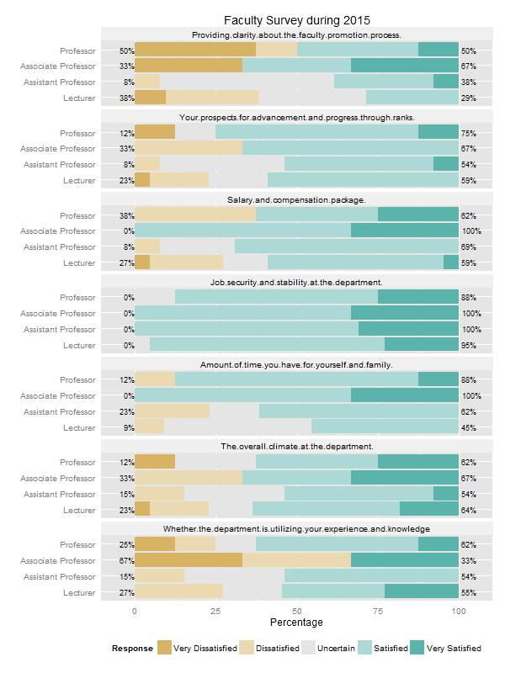

The percentages give a visual overview of the 46 respondents. Although it is clear from exploratory analysis which questionnaires have greater mean values than others. Using bootstrapping to determine the statistics from 46 respondents for the confidence intervals for various mean values is plotted below.

We used the likert-scale of 1-5 for the five questionnaire options and Boot Statistics was calculated for each indicator using 1000x no. of samples with replacements, and histograms for the confidence levels of mean values was plotted for a visual comparison with the faculty survey conducted during 2013 with each indicator as given below:

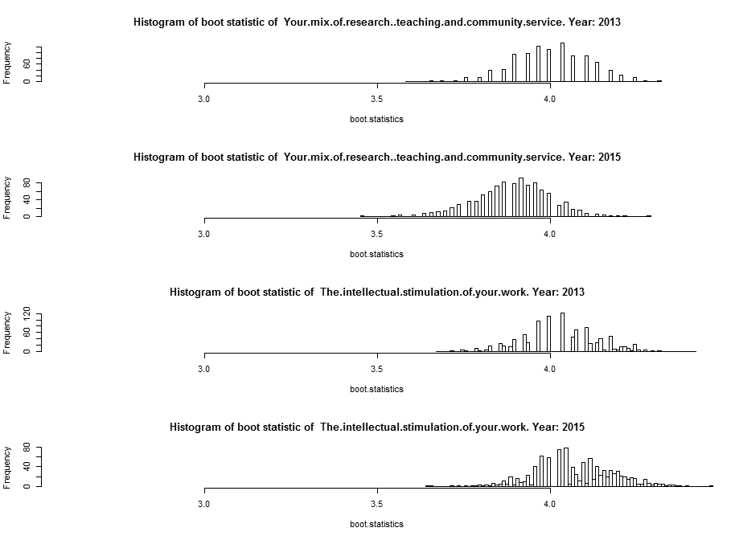

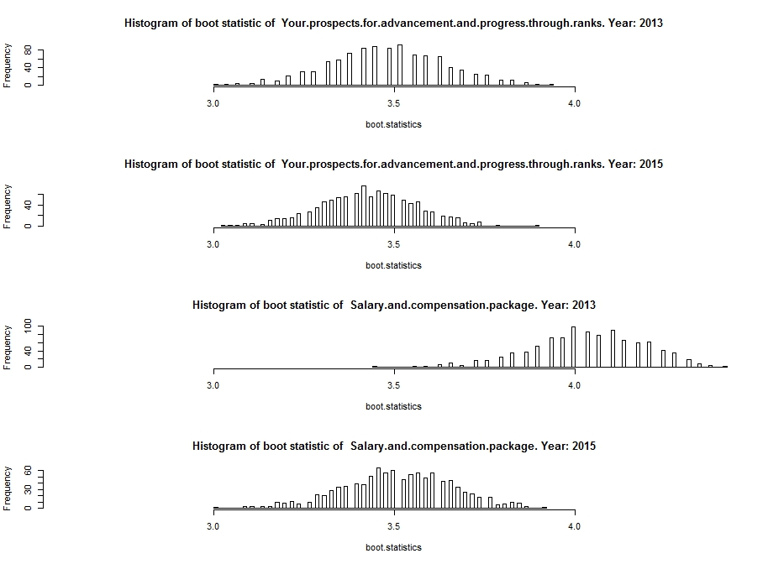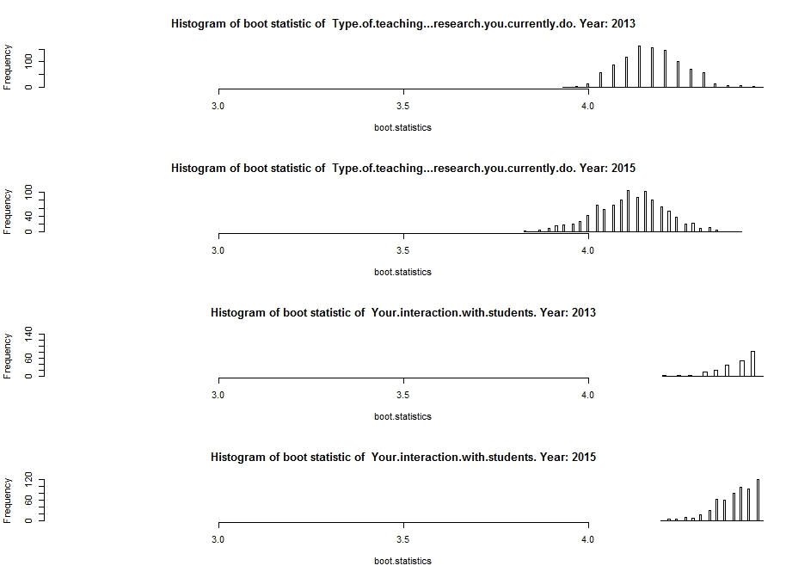

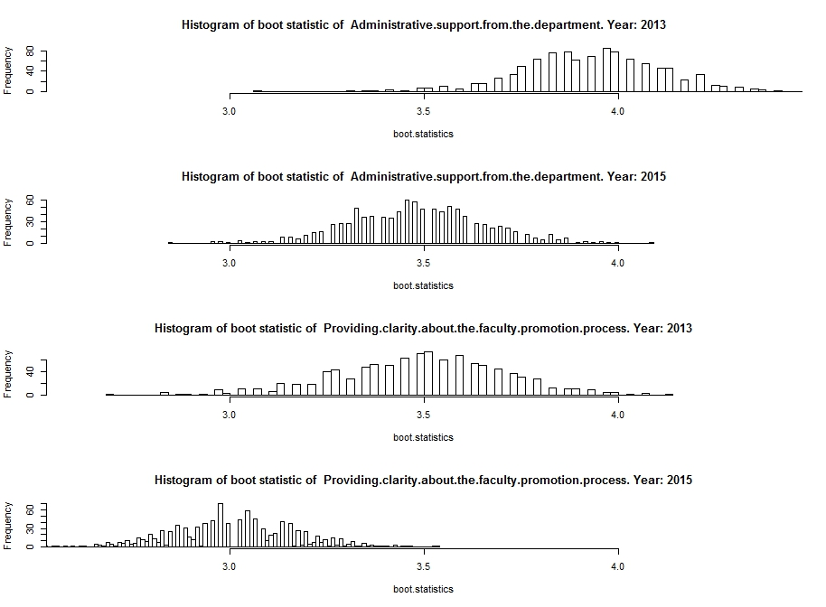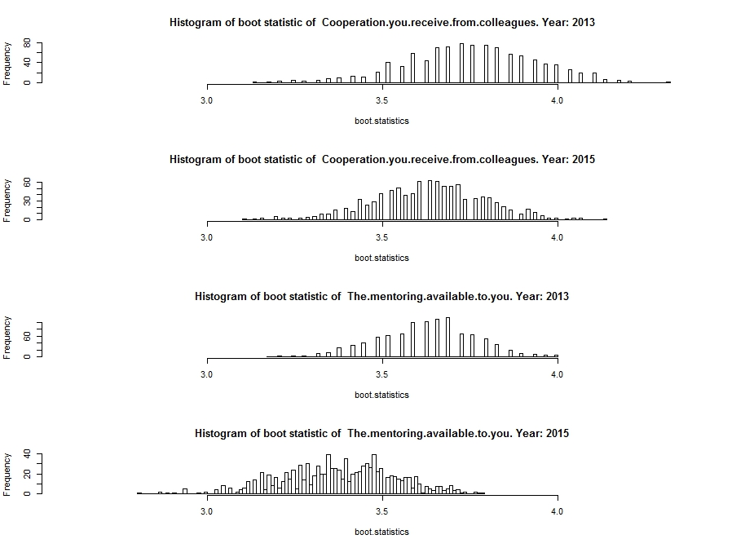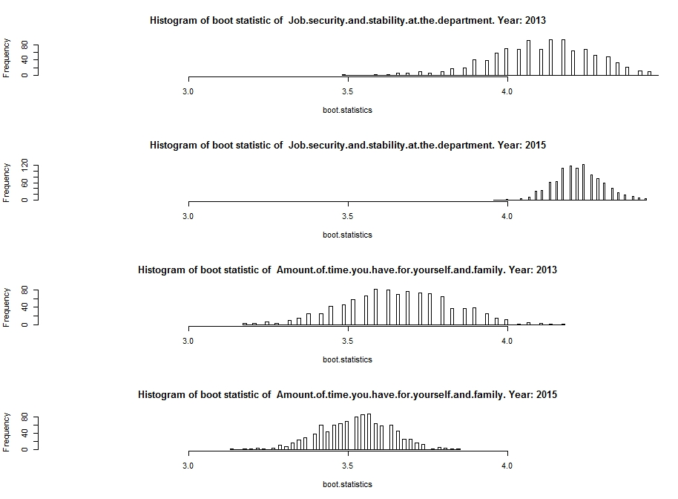

From the above plots, we observe that there are three questionnaires whose responses differ widely between the two years (i.e. during 2013 and 2015) which are below:

1. Salary and Compensation Packages
2. Administrative support from the department &
3. Providing Clarity about faculty promotion process

We want to run the t-test statistics on the original data to see if they are significantly different between the years 2013 and 2015.

# Salary and Compensation Packages

Welch Two Sample t-test

t = 2.4697, df = 65.237, p-value = 0.01615

alternative hypothesis: true difference in means is not equal to 0

95 percent confidence interval:

0.1023082 0.9666573

sample estimates:

mean of x mean of y

4.034483 3.500000

# Administrative support from the department

Welch Two Sample t-test

t = 1.8032, df = 65.813, p-value = 0.07593

alternative hypothesis: true difference in means is not equal to 0

95 percent confidence interval:

-0.04857099 0.95411822

sample estimates:

mean of x mean of y

3.931034 3.478261

## Providing Clarity about faculty promotion process

Welch Two Sample t-test

t = 1.7059, df = 57.451, p-value = 0.09342

alternative hypothesis: true difference in means is not equal to 0

95 percent confidence interval:

-0.08382087 1.04933811

sample estimates:

mean of x mean of y

3.482759 3.000000

From the above three tests, it is clear that the significant difference is only in the 1st Questionnaires’ responses i.e. **Salary and Compensation Packages** between the years 2013 and 2015**.** The other two are not significantly different between the years 2013 and 2015.

**RESULT:**

We have used various exploratory and statistical techniques to determine which questionnaires have different responses between the two years 2013 and 2015 and conclude that the responses of Questionnaire **“Salary and Compensation Packages”** has declined during the year 2015 from mean values of 4.03 to 3.5 with a p-value of 0.01615. The other two questionnaires’ responses do differ slightly but are not significantly different between the two years.